**Software Engineering Assignment**

**MODULE: 1**

**SE – Overview of IT Industry**

1. **What is software? What is software engineering?**

.

* Software is a collection of instructions or code that tells a computer or device how to perform specific tasks. It can be categorized into two main types: system software and application software.

1. System software: System software includes the operating system, which manages the hardware and software resources of a computer. It provides a platform for other software to run on. Examples of operating systems are Windows, macOS, and Linux.
2. Application software: It is designed to perform specific tasks or provide certain functionality to users. This can include productivity tools like video editing programs, or even games and entertainment apps.

* Software engineering: Software engineering is a field that focuses on the design, development, and maintenance of software systems. It involves applying engineering principles and practices to create high-quality, reliable, and efficient software.

* Software engineering require some key processes:

1. Requirements Analysis.
2. Design.
3. Implementation.
4. Testing.
5. Deployment.
6. Maintenance.

**2. Explain types of software.**

* Mainly there are two types of software:

1. System software.
2. Application software.

* System software:
* System software includes the operating system, which manages the hardware and software resources of a computer. It provides a platform for other software to run on.
* It provides essential services and functionalities necessary for the proper functioning of a computer or device.
* One of the key components of system software is the operating system (OS).
* Operating system: It is responsible for managing and controlling the hardware resources of a computer or device. It acts as an intermediary between the user and the computer's hardware, enabling users to interact with the system through a user-friendly interface. Operating systems like Windows, macOS, and Linux are examples of popular operating systems.
* Application software.
* Application software refers to the programs and applications that are designed to perform specific tasks or provide specific functionalities for users. Unlike system software, which provides a platform for other software to run on, application software is directly used by individuals to accomplish various purposes.
* Some types of Application software:

1. Productivity Software: This includes programs like word processors (e.g., Microsoft Word, Google Docs), and presentation software (e.g., Microsoft PowerPoint, Google Slides). These tools help users create, edit, and manage documents, spreadsheets, and presentations.
2. Communication Software: Applications like email clients, instant messaging apps (e.g., WhatsApp, Facebook Messenger), and video conferencing tools (e.g., Zoom, Skype) fall into this category.
3. Gaming Software: Video games, both on computers and mobile devices, are a popular form of application software.
4. **What is SDLC? Explain each phase of SDLC.**

* SDLC stands for Software Development Life Cycle.
* **The Software Development Life Cycle (SDLC)**is a process used by software development organizations to plan, design, develop, test, deploy, and maintain software applications.
* SDLC consists of several phases, each with its own specific tasks and goals.

1. Requirements Gathering: This phase involves gathering information about the software requirements from stakeholders, such as customers, end-users, and business analysts.
2. **Design:** In this phase, the software design is created, which includes the overall architecture of the software, data structures, and interfaces.
3. Development: This phase involves coding and programming the software based on the system design. Developers write the code. They also conduct testing to ensure the code functions as expected.
4. **Testing:**The software is thoroughly tested to ensure that it meets the requirements and works correctly.
5. Deployment: After successful testing. The software is deployed to a production environment and made available to end-users.
6. Maintenance: After deployment, the software enters the maintenance phase. This involves fixing bugs, regular updates and improve functionality.
7. **What is DFD? Create a DFD diagram on Flipkart.**

* **DFD** stands for **Data Flow Diagram**. It is a graphical representation that shows how data flows within a system.
* It visually represents the flow of data throughout processes in a given system. DFD shows the kind of information that will be input to and output from processes as well as where the data will be stored.

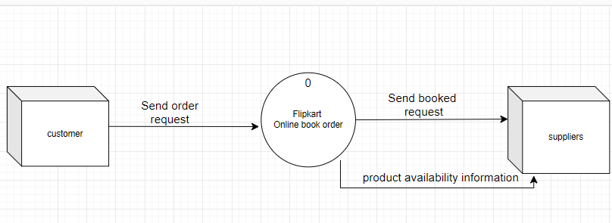

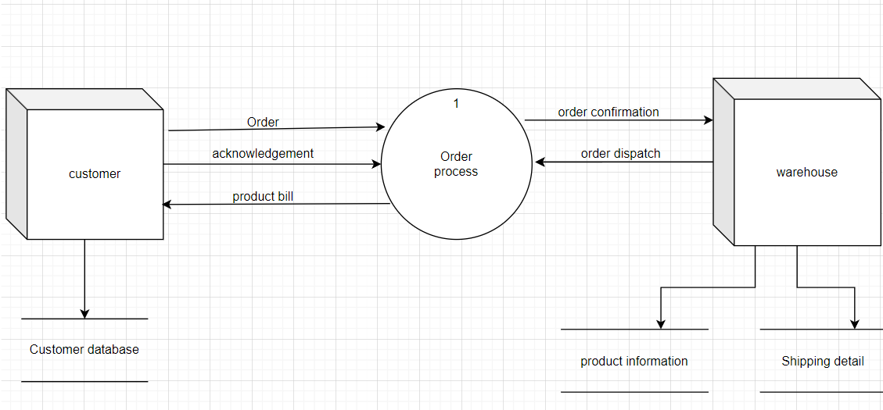

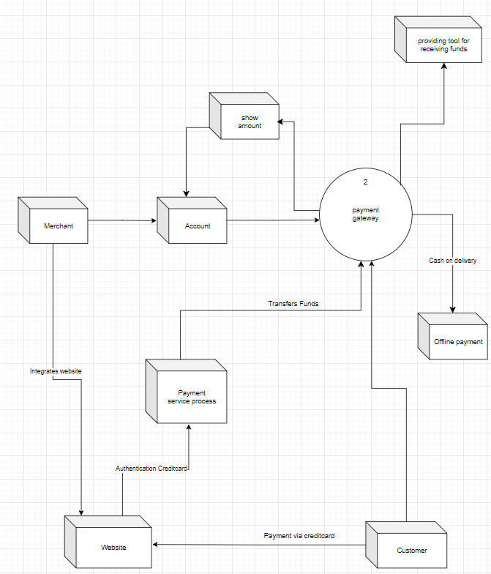

1. What is Flow chart? Create a flowchart to make addition of two numbers.

* A flowchart is a type of diagram that represents a workflow or process. A flowchart can also be defined as a diagrammatic representation of an algorithm, a step-by-step approach to solving a task.

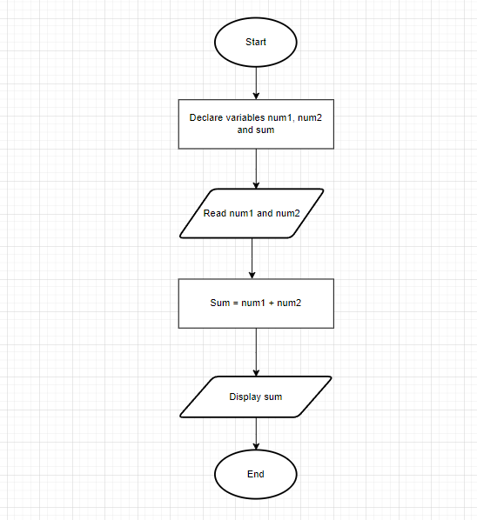

1. What is Use case Diagram? Create a use-case on bill payment on paytm.

* Use-case diagrams describe the high-level functions and scope of a system. These diagrams also identify the interactions between the system and its actors. The use cases and actors in use-case diagrams describe what the system does and how the actors use it.

